Ideation Phase
Brainstorm & Idea Prioritization Template

Date | 28 SEPTEMBER 2026
Team ID | SWTID-2026-4636
Project Name | AI BLOGNESTAPI
Maximum Marks | 4 Marks

Brainstorm & Idea Prioritization Template:
Problem Statement
Many users want to create and manage blog content easily, but manually writing, editing, categorizing, and managing blog posts can take a lot of time. Existing blogging platforms may also contain unnecessary features and complicated interfaces.
AI BlogNest API is proposed as a simple backend system that provides APIs for creating, managing, and organizing blog content. The system can use AI-based features to assist with content generation, summarization, categorization, and improvement while providing secure user authentication and database management.
Step 1: Team Gathering, Collaboration and Select the Problem Statement
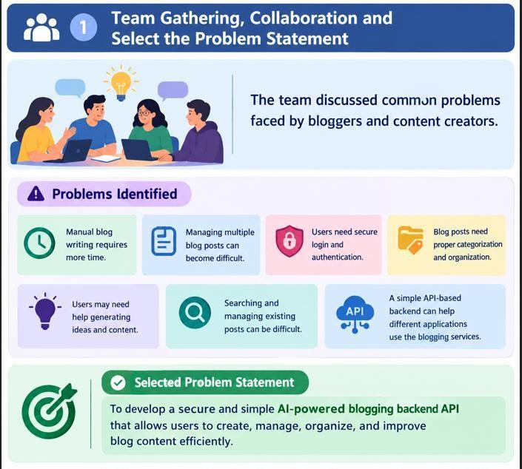
Step 2: Brainstorm, Idea Listing and Grouping
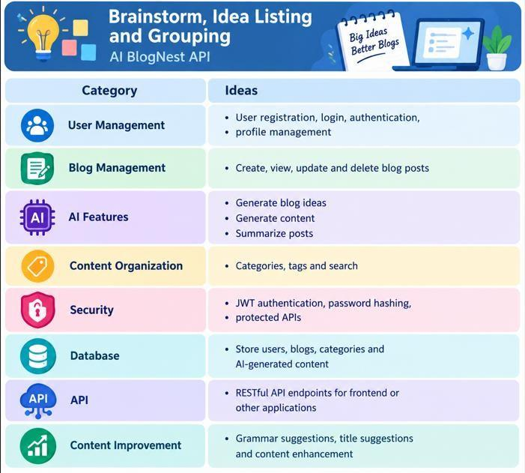

Step 3: Idea Prioritization

The team prioritized the ideas based on feasibility, usefulness, security, implementation effort and project value.
